DLD LAB-1

Question No:1

| Input a | Input b | Output z |
| --- | --- | --- |
| 0 | 0 | 1 |
| 0 | 1 | 0 |
| 1 | 0 | 1 |
| 1 | 1 | 1 |

Question No:2

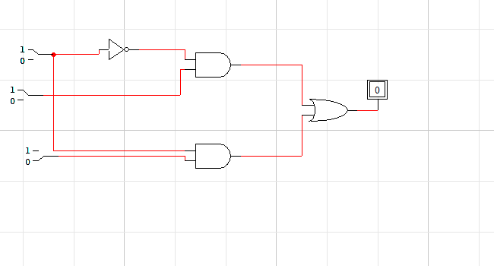

| **Input x** | **Input y** | **Input z** | **Output f** |
| --- | --- | --- | --- |
| **0** | **0** | **0** | **0** |
| **0** | **0** | **1** | **0** |
| **0** | **1** | **0** | **0** |
| **0** | **1** | **1** | **1** |
| **1** | **0** | **0** | **1** |
| **1** | **0** | **1** | **0** |
| **1** | **1** | **0** | **1** |
| **1** | **1** | **1** | **1** |

QUESTION NO:3

| Input a | Input b | Input c | Input d | Output f |
| --- | --- | --- | --- | --- |
| 0 | 0 | 0 | 0 | 1 |
| 0 | 0 | 0 | 1 | 1 |
| 0 | 0 | 1 | 0 | 0 |
| 0 | 0 | 1 | 1 | 0 |
| 0 | 1 | 0 | 0 | 1 |
| 0 | 1 | 0 | 1 | 1 |
| 0 | 1 | 1 | 0 | 0 |
| 0 | 1 | 1 | 1 | 0 |
| 1 | 0 | 0 | 0 | 1 |
| 1 | 0 | 0 | 1 | 1 |
| 1 | 0 | 1 | 0 | 0 |
| 1 | 0 | 1 | 1 | 0 |
| 1 | 1 | 0 | 0 | 0 |
| 1 | 1 | 0 | 1 | 0 |
| **1** | **1** | **1** | **0** | **0** |
| **1** | **1** | **1** | **1** | **0** |

Question No:4

Part 5

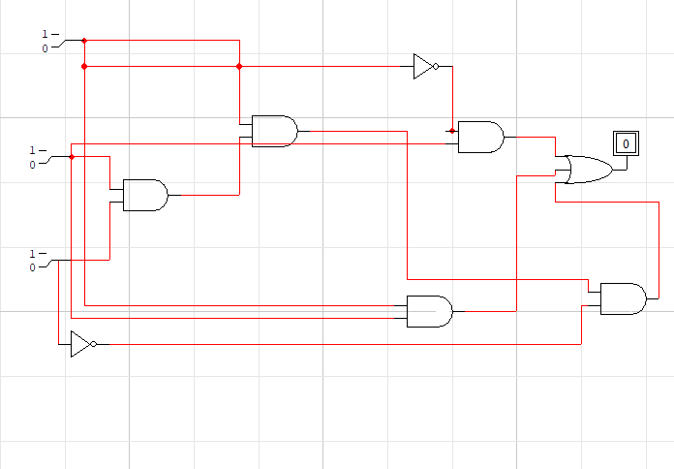

Question No:4

Part 6

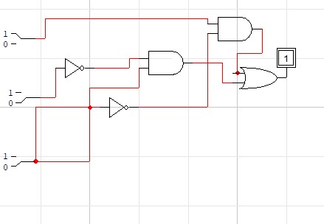

Question No:4

Part:7

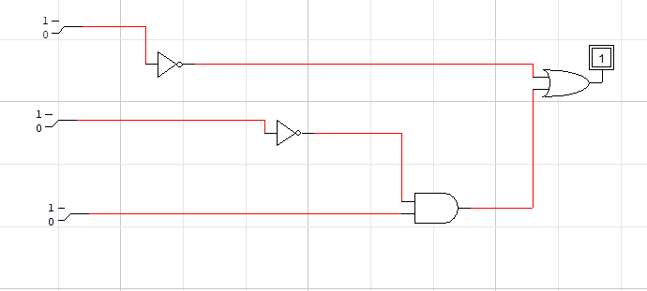

Question No:4

Part:1

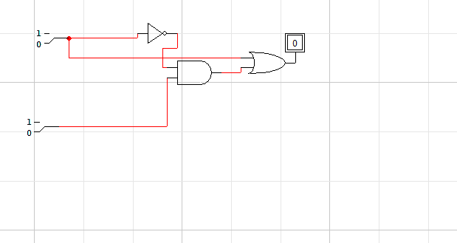

Question No:4

Part:2

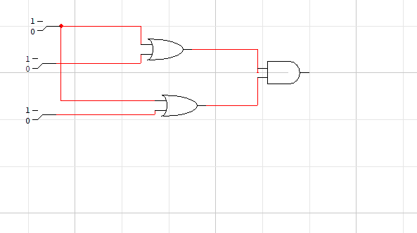

Question No:4

Part:3

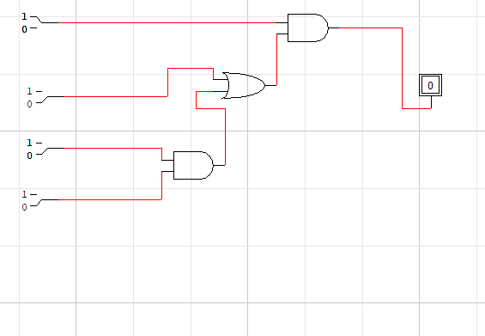

Question No:4

Part:4

